# **Overall Risk Dashboard**

The overall risk dashboard gives you a quick overview of your organization’s current performance in different scan categories (Vulnerability, Security Baseline, Sensitive Data, Compliance); risk quantification data in monetary terms; compliance status; and risk mitigation efforts.

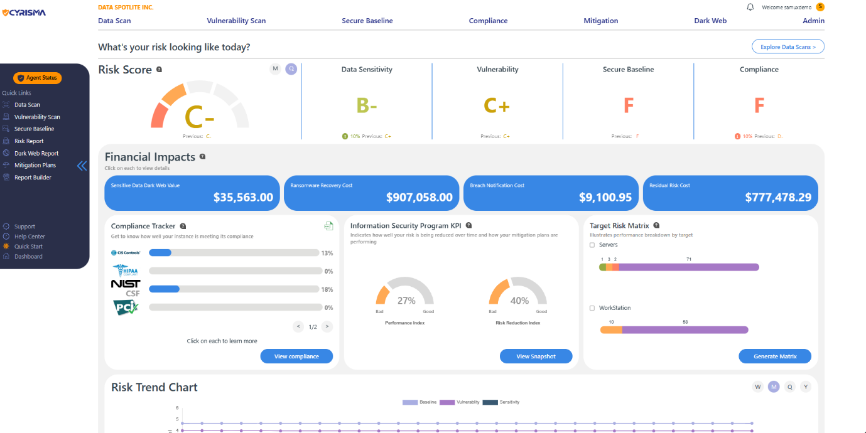

View your organization’s risk monetization data – estimated monetary losses in the event of an attack; assess compliance with top cybersecurity regulatory frameworks and best practice standards, and view performance in different scan categories at a glance.

## **Estimate of monetary losses due to potential security incidents**



**Residual   
Risk Cost**

The “residual” cost that remains after putting security controls in place, and how it can be lowered. Based on questions cyber insurance companies will ask and the risk cost associated with not having appropriate solutions.

**Sensitive Data   
Dark Web value**

The dark web value of the sensitive data discovered in your environment. Sensitive data may include Credit Card numbers, Social Security Numbers, Passwords, PII, and more (choose from dozens of data categories)

**Ransomware   
Recovery Cost**

The cost to recover in case your organization is hit by a ransomware attack. Includes system recovery costs based on the number of machines and employees affected, downtime costs, and sensitive data value.

**Data Breach   
Notification Cost**

Cost to notify persons (past and existing customers, partners & others) whose data was compromised due to a security incident. Covers investigation costs, fines, class action lawsuits corresponding with each sensitive data category.

## **Residual Risk Cost**

See your Residual Risk cost go down as you implement essential security controls and check them off the Residual Risk Adjustment Questionnaire.

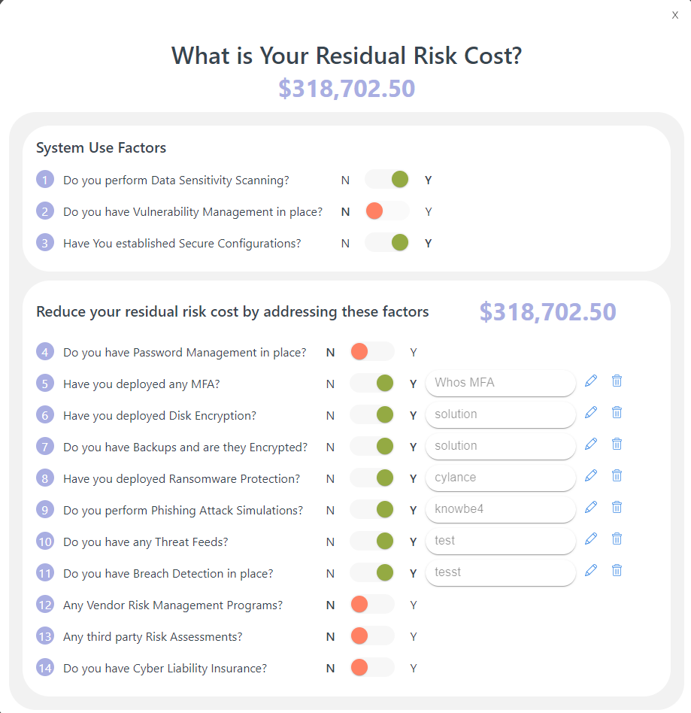

## **Overall and Category-Specific Risk Grades**

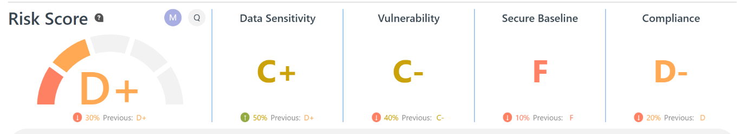

**Compliance**

The Compliance Grade is based on the aggregate performance of the organization on compliance assessments against the frameworks and standards relevant to the country / industry.

**Overall Risk Grade**

The overall risk grade is based on a combination of vulnerability, sensitive data, secure baseline scan, and compliance assessment results.

**Data Sensitivity**

The Data Sensitivity grade is based on the volume and type of sensitive data found on your company’s systems (on-prem and cloud). Track progress by comparing past and present risk grades.

**Vulnerability Management**

The Vulnerability Grade is based on Internal Authenticated & Unauthenticated, External, and Web App scans across your organization’s computing environments.

**Secure Baseline**

The Baseline grade is based on performance in secure configuration scans on different operating systems. Compare OS configuration settings against established security frameworks.

## **Risk Trend**

View performance in each of the three scan categories - Data Sensitivity, Vulnerability Management, and Secure Baseline - over a selected period of time, based on risk levels A through F.

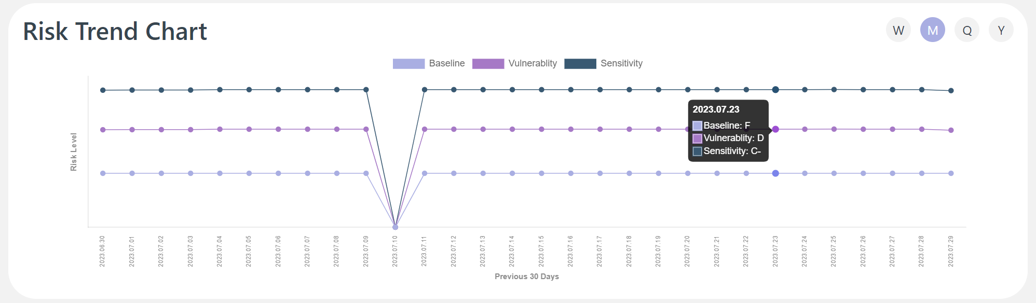

## **Compliance Tracker**

Track your organization’s compliance with regulatory and best practice frameworks like PCI DSS, HIPAA, NIST CSF and the CIS Controls

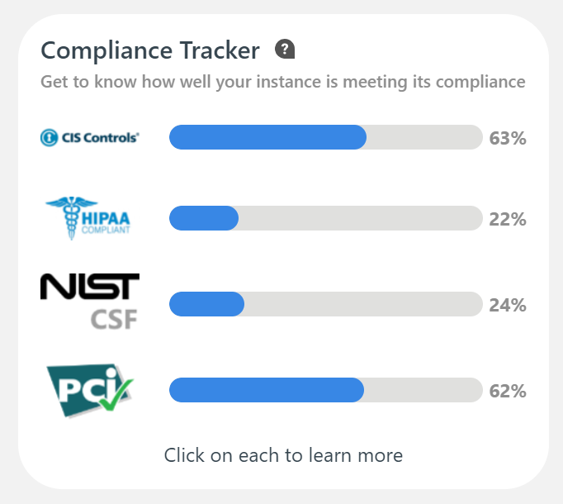

## **Compliance Tracking Checklist**

Map your existing security processes to specific Security Frameworks like the CIS Critical Controls, NIST CSF, PCI DSS or HIPAA to determine which requirements are being met and which ones need action

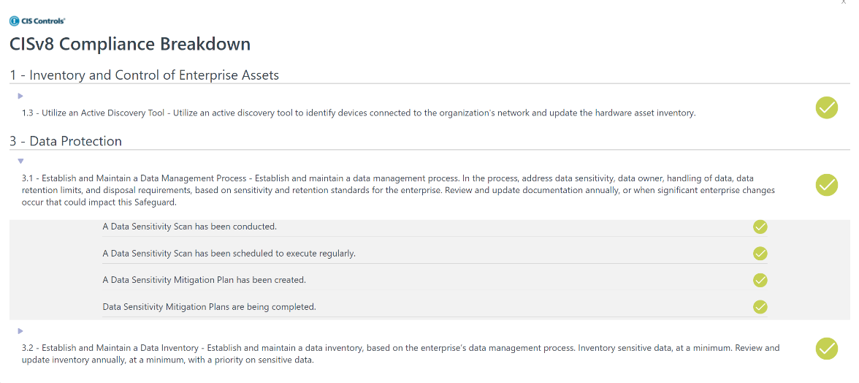

## **Assigned Mitigation Plans**

Get an overview of mitigation plans in progress – total number of plans, completed scans, the progress percentage on each scan, and more.

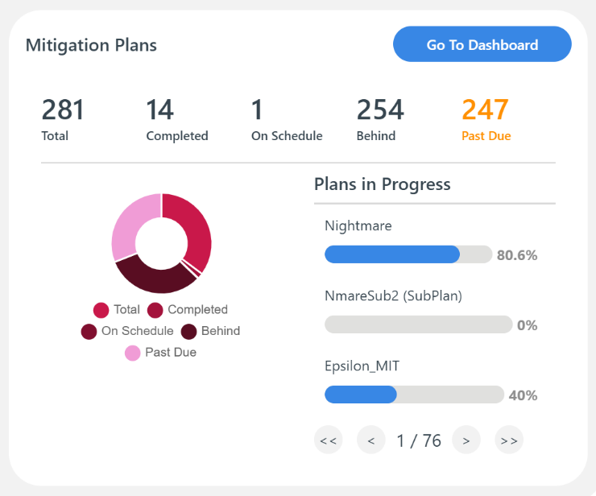

## **Agent and Target Status**

Easily manage your Agents and the Targets on which Agents are deployed. Get quick access to information about online and offline Agents, and the number of Targets (systems or devices) covered under each scan category.

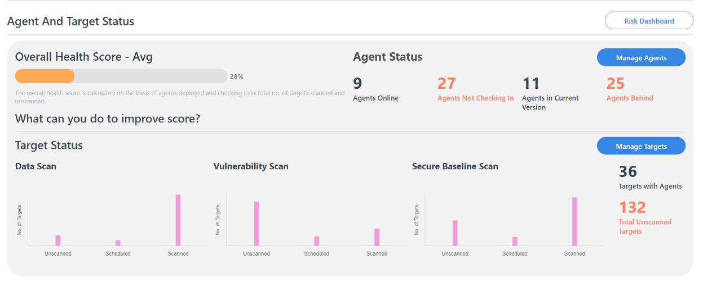

## **Report Builder**

Use the Report Builder to generate reports for completed scans in any category. Choose between an Executive Summary with key information and a more comprehensive Full Detail report.

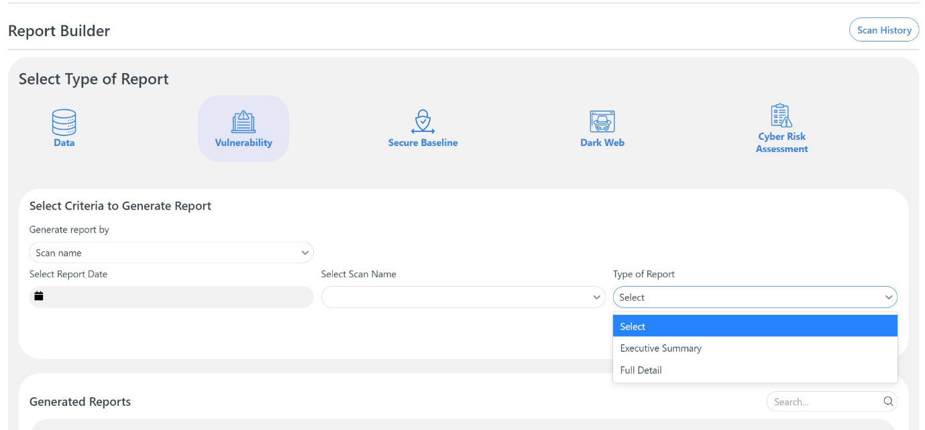

## **Overall Risk Assessment Report**

Generate an Overall Risk Assessment Report after Completing a Set of Scans (External Vulnerability, External Web Application, Internal Authenticated Vulnerability, Data Sensitivity, Secure Baseline, Dark Web)

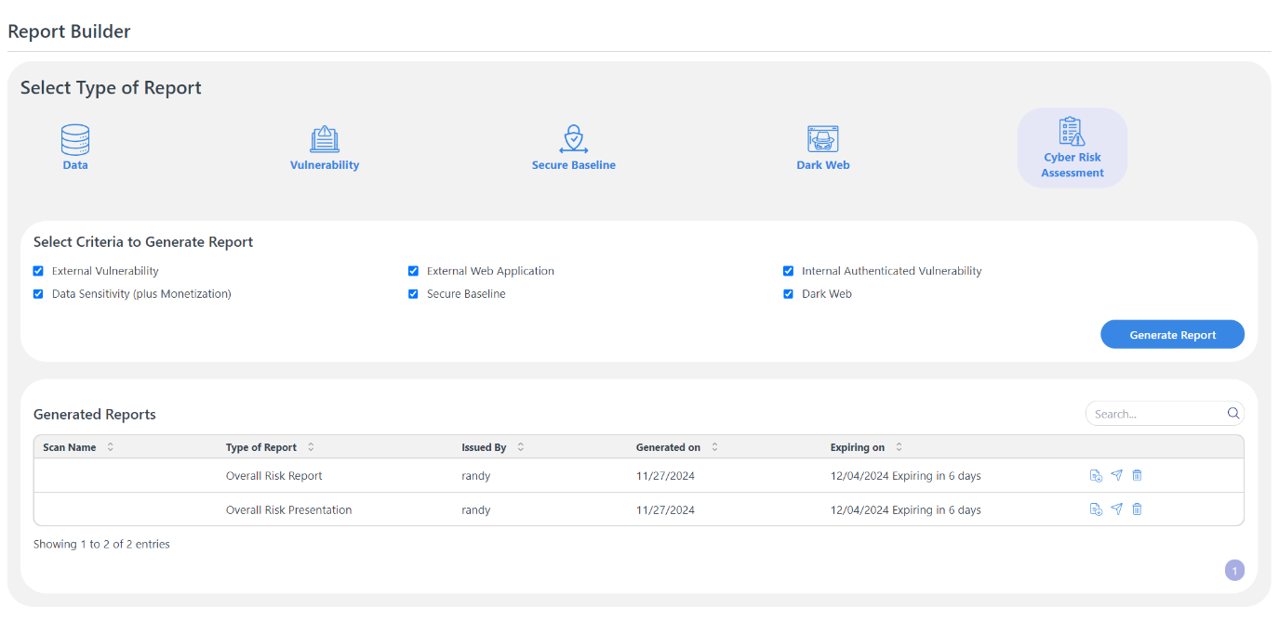

## **Quick Start**

With the Quick Start feature, you can set up the most commonly used scans and install an Agent in a few easy steps to start seeing actionable information quickly. Kick-start vulnerability scans for External IPs and Web Apps, set up a Dark Web Monitor, and install an Agent.

