# **Vulnerability Management**

Perform Internal (Authenticated & Unauthenticated), External, and Web App Vulnerability Scans, understand the vulnerabilities discovered, and create data-driven mitigation plans to quickly close security gaps and prevent cyber attacks.

Patch third-party Windows-based apps from within the platform. Understand the root cause of vulnerabilities (tracked as CVE numbers), assess business impact, and prioritize remediation. Compare scan results and performance over time.

## **Vulnerability Scan Dashboard**

The Vulnerability Scan Dashboard gives you an overview of vulnerability scan results over your selected time period, mitigation information and progress over time.

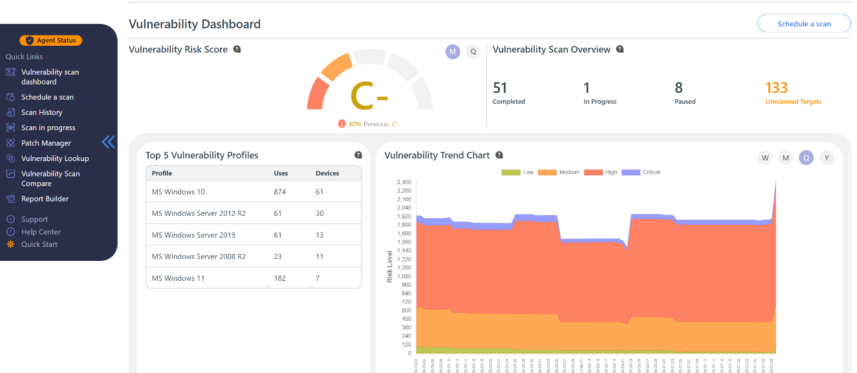

The simple risk grading system (A=Good; F=Bad) provides a high-level idea of your current risk status based on the vulnerability scans performed over the last month or quarter.

The Risk Trends chart shows you the number and severity of vulnerabilities (broken down by) found in your environment over a given period of time (Week/Month/Quarter/Year).

## **Targets with the most vulnerabilities**

Easily discover machines that have the most vulnerabilities within the current selected reporting period and take steps to secure them quickly.

## All Vulnerabilities and the Impacted Hosts

View the number of Unique CVEs for Workstations (Laptops and PCs) and Servers, broken down by severity.

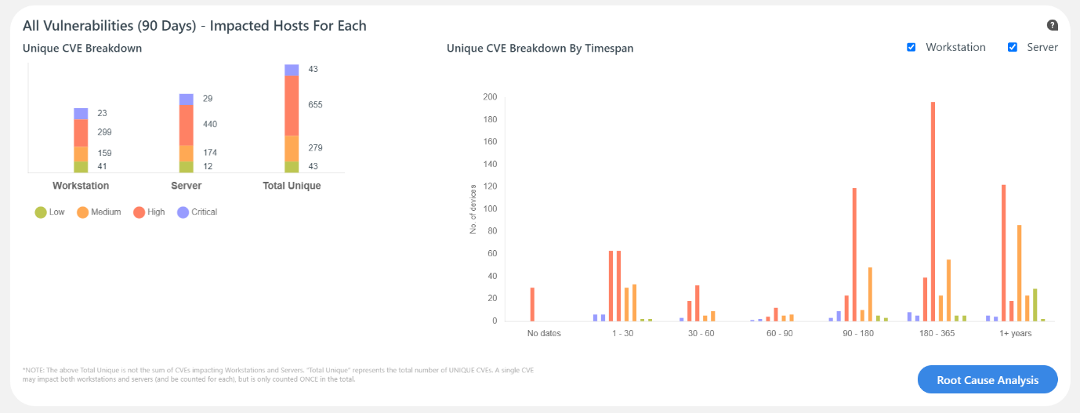

## Patch Management

Patch vulnerabilities in a wide range of Windows-based third-party apps and view patch status on Targets (machines) across your environment.

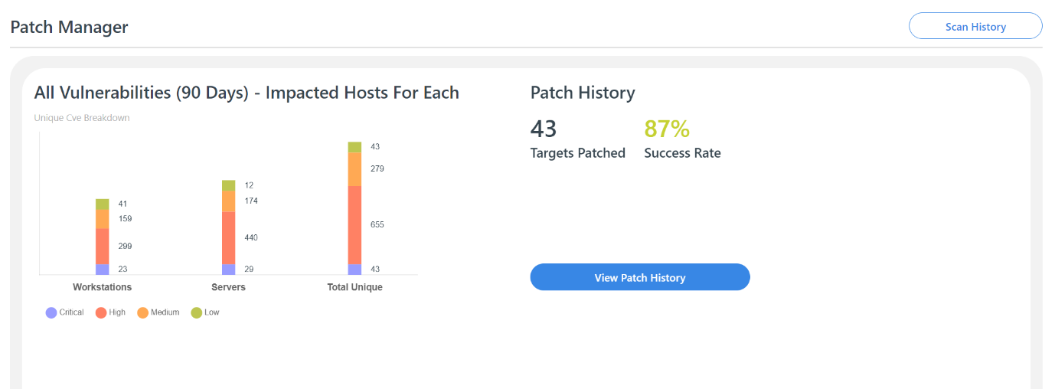

## Root Cause Analysis

Drill-down into the root causes of CVEs in the environment, and the systems affected by each. Schedule patches and software updates to address different root causes.

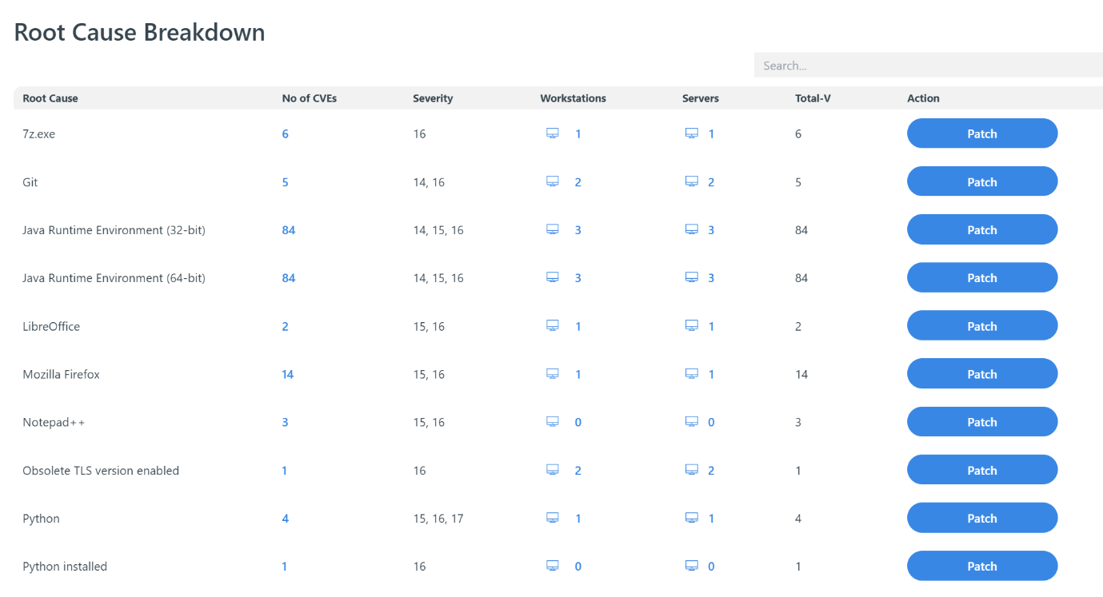

## Patch History

View a complete list of patches applied so far, with details about the date and time when each patch was deployed on specific Targets, the Agent involved, patch software, whether the patch was successful, and log information for troubleshooting.

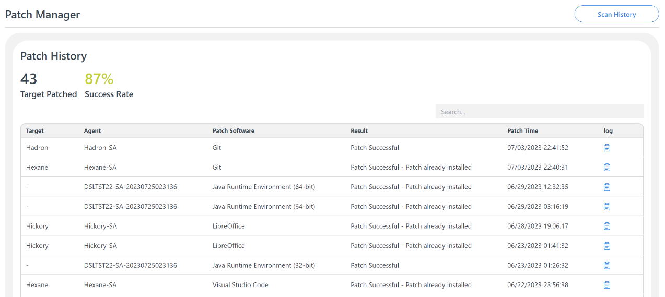

## Vulnerability History

View vulnerability scan history by scan type. The information shown includes scan names, all the targets scanned, individuals who issued the scans, start and end dates, no. of vulnerabilities found broken down by severity, mitigation options and Actions to take.

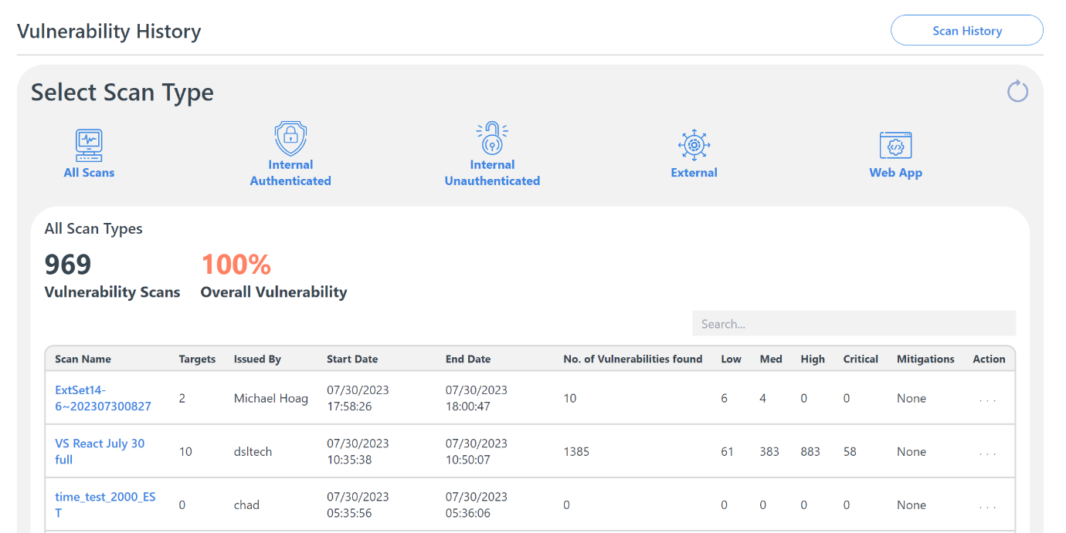

## **Vulnerability Scan Reports**

Easily generate vulnerability scan reports using the Report Builder. Choose between an Executive Summary and Full Detail Reports.

Maintain a low level of vulnerability risk by scanning devices regularly & taking immediate action when new vulnerabilities are found.