# **Sensitive Data Discovery**

Discover the sensitive data in your cloud and on-prem environments. Scan company systems, email inboxes, Microsoft Office 365 (Exchange 365, SharePoint, OneDrive) and Google Cloud (Gmail messages and attachments, Google Drive, other Google Workspace apps) for any sensitive data that isn’t adequately protected.

Understand what sensitive data was found, where it was found and the associated risk for your business. Mitigate risk by taking immediate steps to secure this data.

## **Data Scan Dashboard**

* Scan systems for dozens of sensitive data categories (Credit Card numbers, Social Security Numbers, Passwords, PII and much more).
* View current and previous performance grades based on data scan results.
* Get a quick overview of the top data categories scanned and scan trends over time.

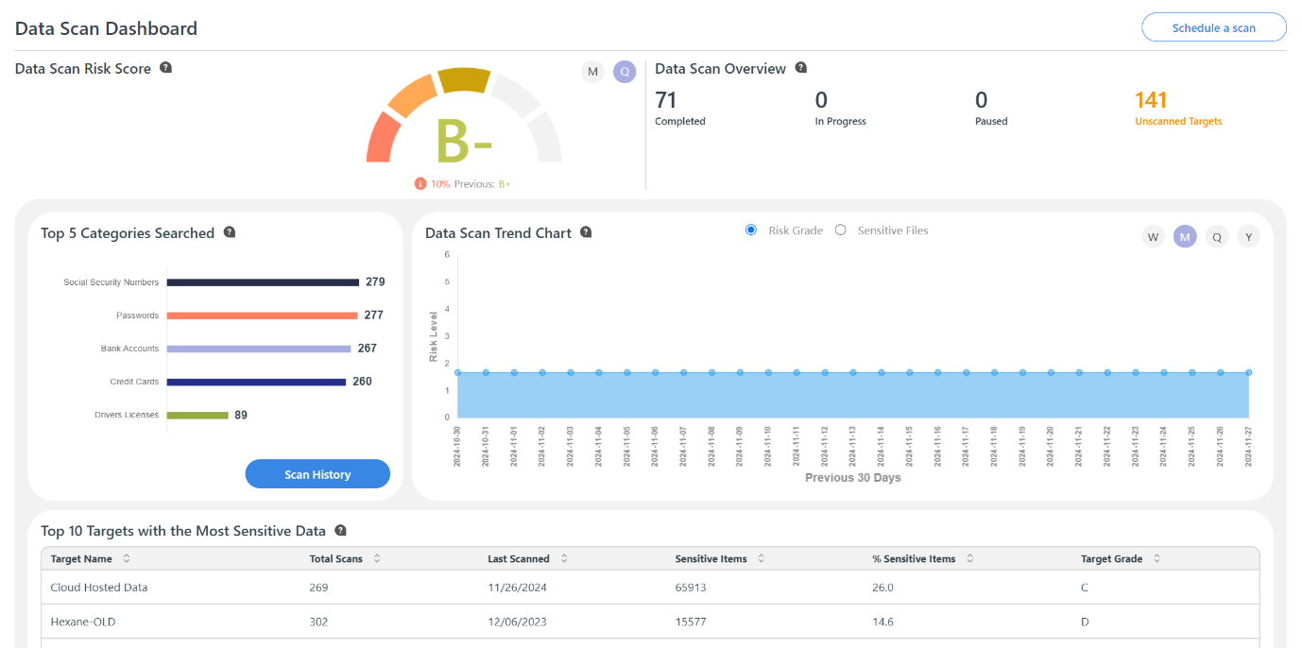

## **Top Targets with Most Sensitive Data**

Easily prioritize data protection tasks based on information about where your most sensitive data resides.

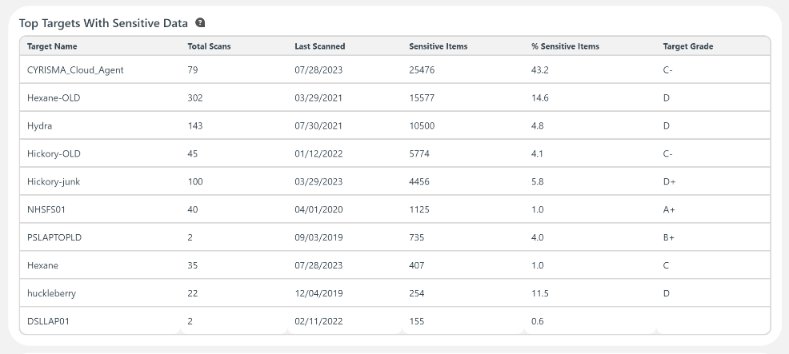

## **Data Category Analysis**

View the overall category breakdown of what sensitive data was discovered during scans. See exactly which items were found for a particular category.

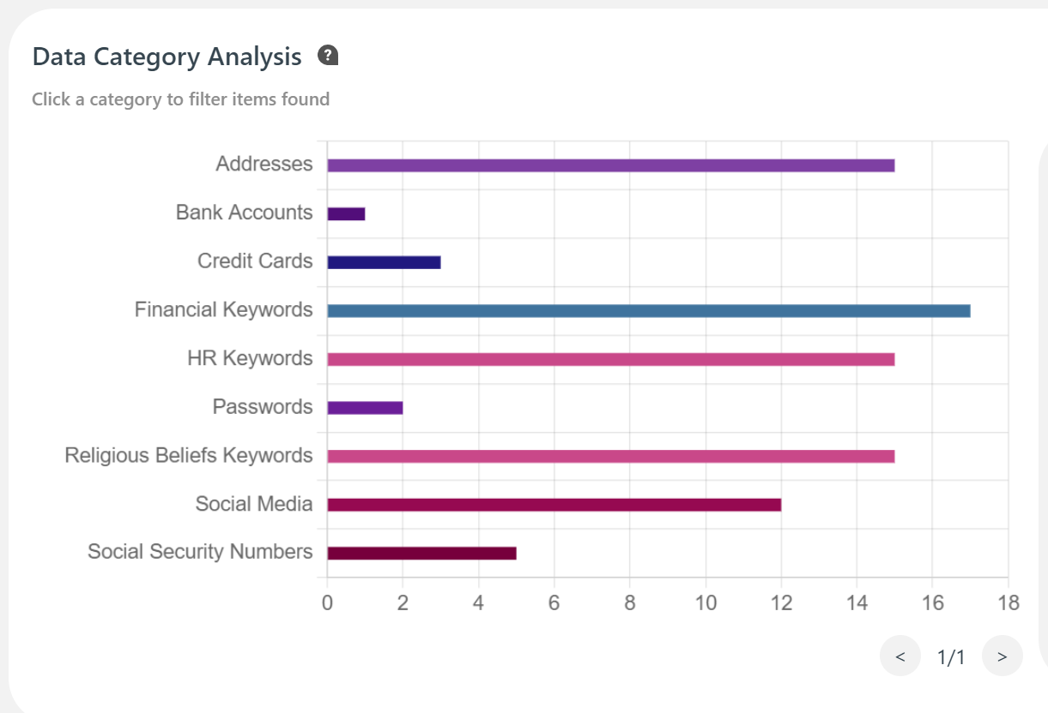

**Sensitive Data Scan History**

View scan history, easily schedule and run scans, and create mitigation plans to secure the sensitive data found.

Mitigation actions include deleting, protecting data with a password, encrypting data, changing access permissions or moving it to a secure location.

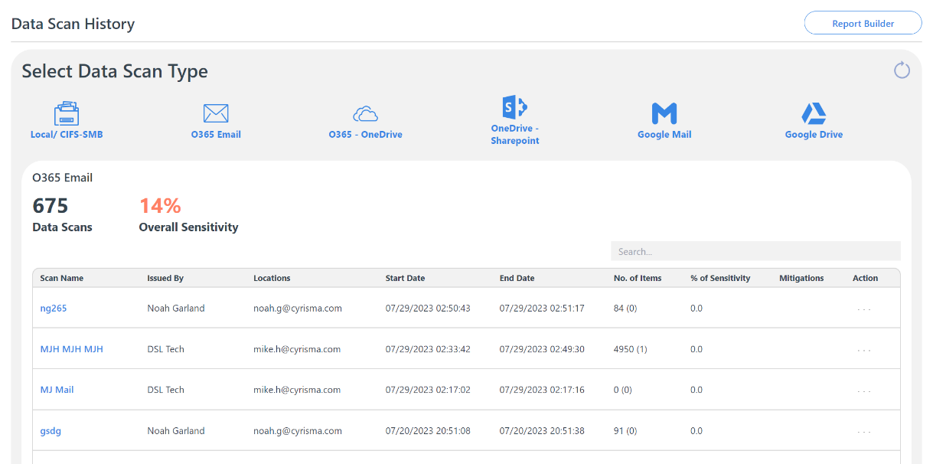

## Mitigation Plans in Progress

Get a quick overview of mitigation plans in progress, with information about who the tasks are assigned to, their due dates, and progress percentage for each.

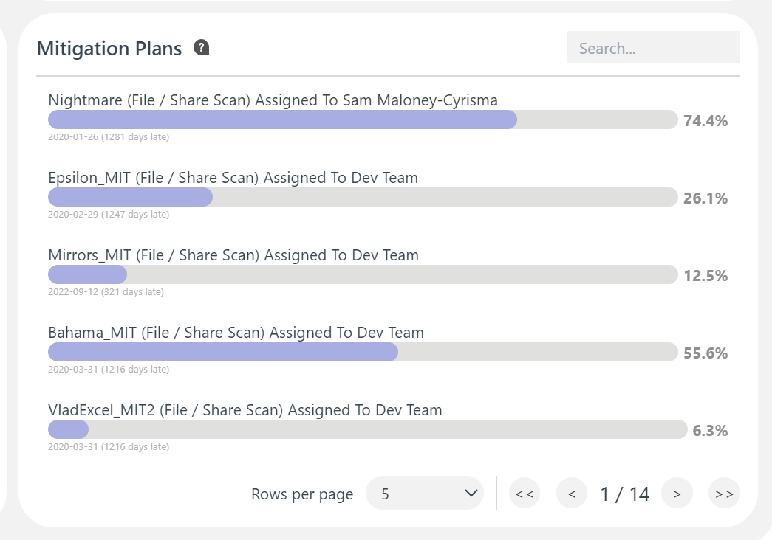

## Data Scan Reports

Easily generate Sensitive Data Scan reports. View Risk Grades, Items found, Sensitive files found & their locations.