# **Dark Web Monitoring**

Monitor the dark web for leaked or stolen company data and underground discussions mentioning your organization, its emails, domains, or IP addresses. View data and posts that go back to up to a year.

Track information in breach records and dark web marketplaces (where your organization’s data may be dumped or be up for sale) and underground forums and ransomware discussions (where hackers may be discussing your data in the context of an attack or a breach.)

## **Track Your Organization’s Information on the Dark Web**

Continually monitor the dark web for data associated with your brand so you can predict and stop attacks that may potentially target your internal systems. Make strategy changes and pivot quickly to stop attacks and control damage.

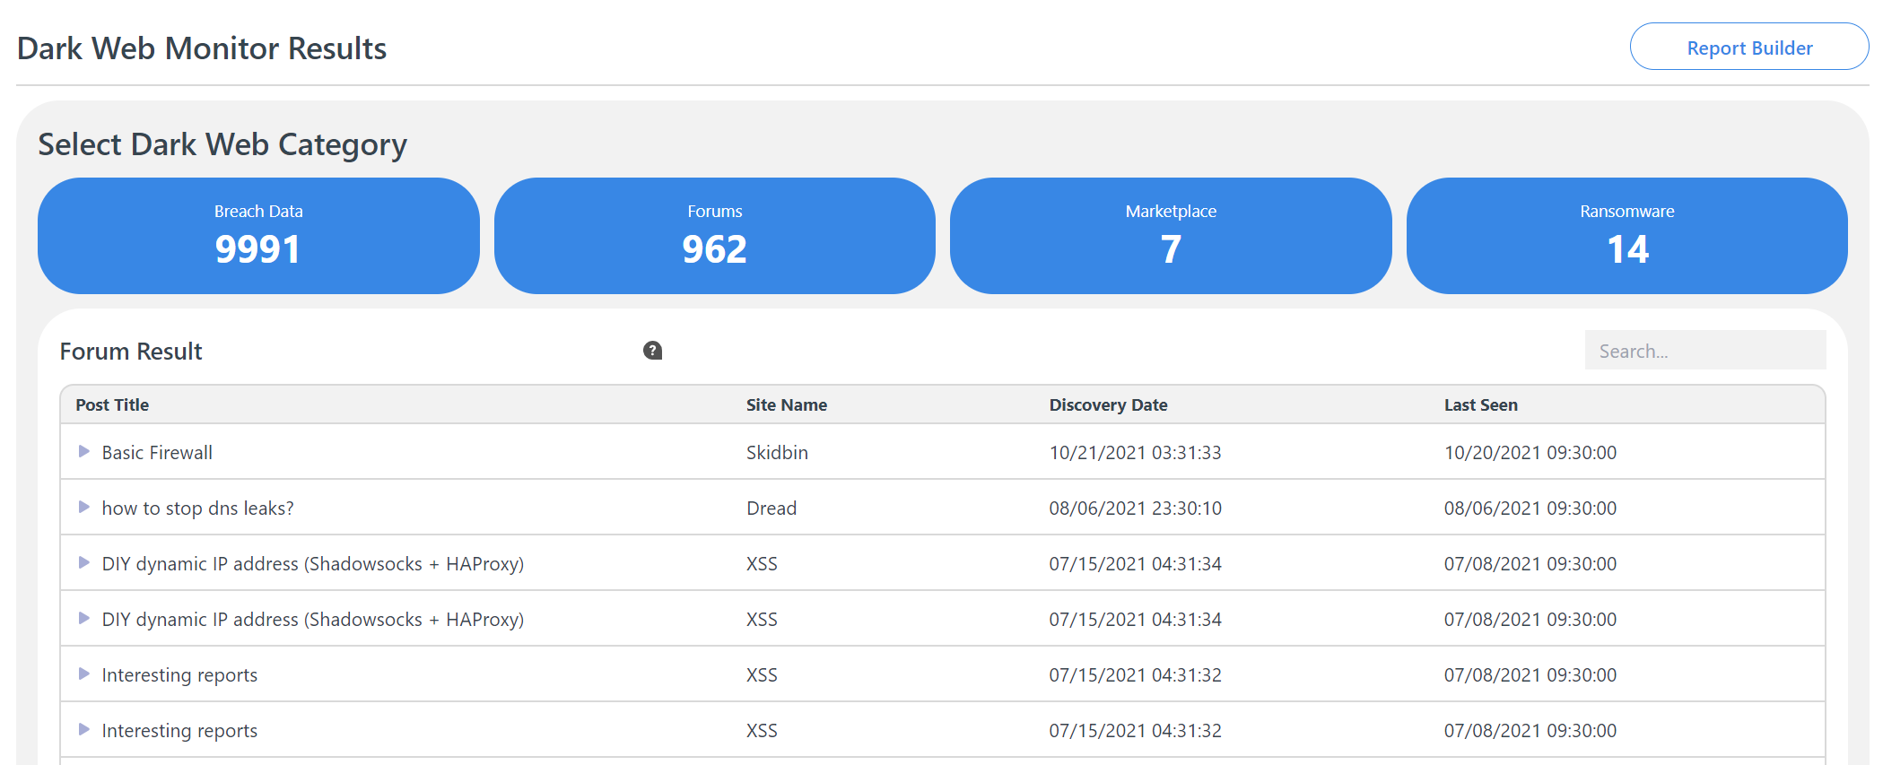

## **Breach Data, Marketplace and Underground Forums**

View breach data including victim accounts, sources where the compromised records were discovered, and discovery

dates. Also monitor any mention of your organization’s emails, domains or IPs in dark web marketplaces, forums and ransomware discussions. Receive notifications when data associated with the company is found on the dark web.

## **Translation Feature**

For dark web discussions in foreign languages, the platform includes a translation feature.