# **Risk Mitigation**

Create data-driven, actionable, and easy-to-track mitigation plans under each scan category (Vulnerability, Sensitive Data Discovery, Secure Baseline) to quickly reduce risk in your environment.

Assign tasks to team members, data owners, or end users; set start and end dates to track progress and stay on top of mitigation efforts.

## **Mitigation Dashboard**

The Mitigation Dashboard shows you the overall status of mitigation plans in different scan categories.

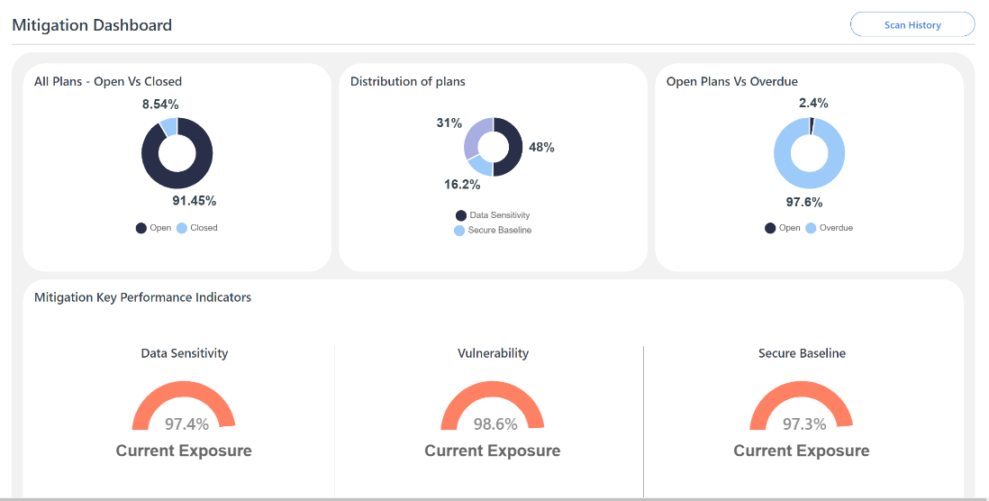

**Get a quick view of:**

* All plans vs closed plans
* Distribution of mitigation plans across scan categories (Data Sensitivity, Secure Baseline, Vulnerability)
* Open plans vs plans that are overdue

## **Top Targets with Most Active Mitigation Plans**

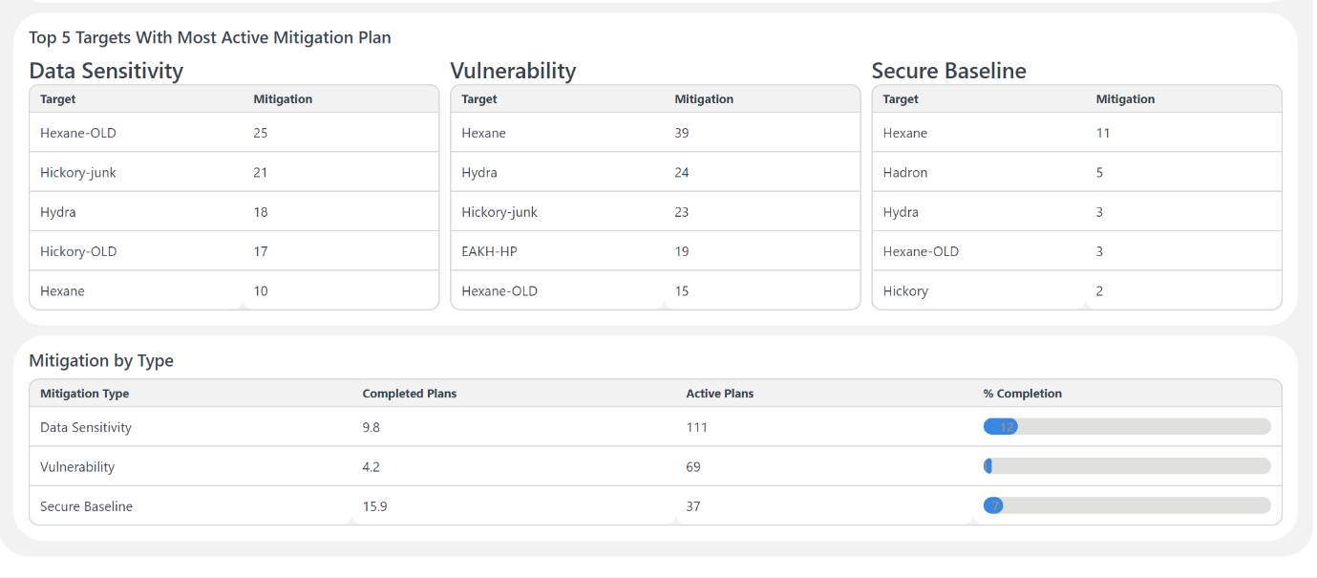

## **Easily Create Mitigation Plans Under Any of the Scan Categories**

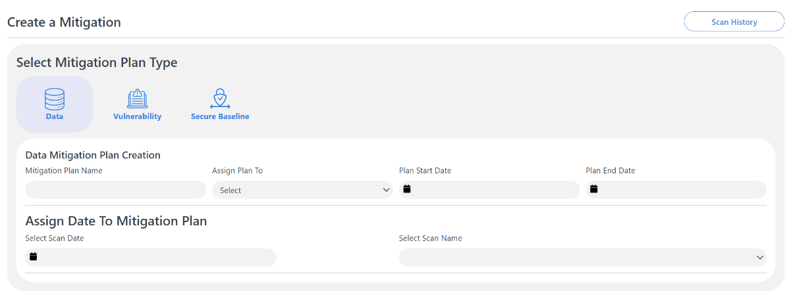

## **Review Progress on All Assigned Mitigation Plans**

Easily review progress on all mitigation plans and re-assign plans in one click.

