# **Compliance**

Move closer to meeting regulatory compliance requirements. Assess compliance against multiple frameworks and implement tactical controls from within the platform. Monitor Active Directory (on-prem and Azure) and Microsoft Secure Score, and compare performance against other organizations in the same industry.

## **Compliance Assessments**

Track and assess your organization’s compliance with regulatory and best practice frameworks like ISO 27001, PCI DSS, HIPAA, CIS Controls and more! Complete compliance questionnaires, upload evidence, assign control to other teams and stakeholders, generate assessment reports with compliance scores, gaps, and customizable recommendations.

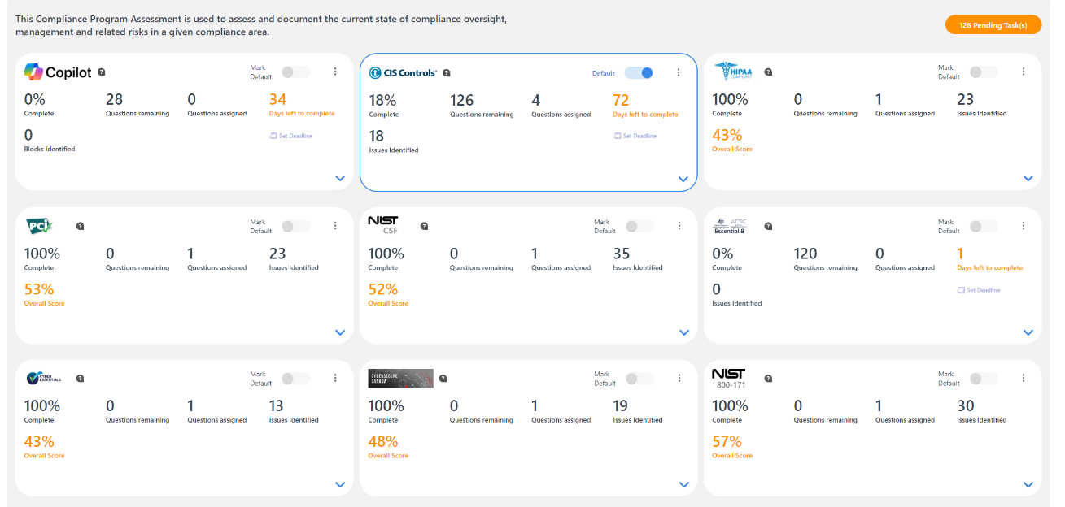

## **Compliance Frameworks Covered**

NIST Cybersecurity Framework, CIS Critical Controls, ISO/IEC 27001, NIST 800-171, HIPAA, PCI DSS, Cyber Essentials (UK), Essential Eight (Australia), CyberSecure Canada

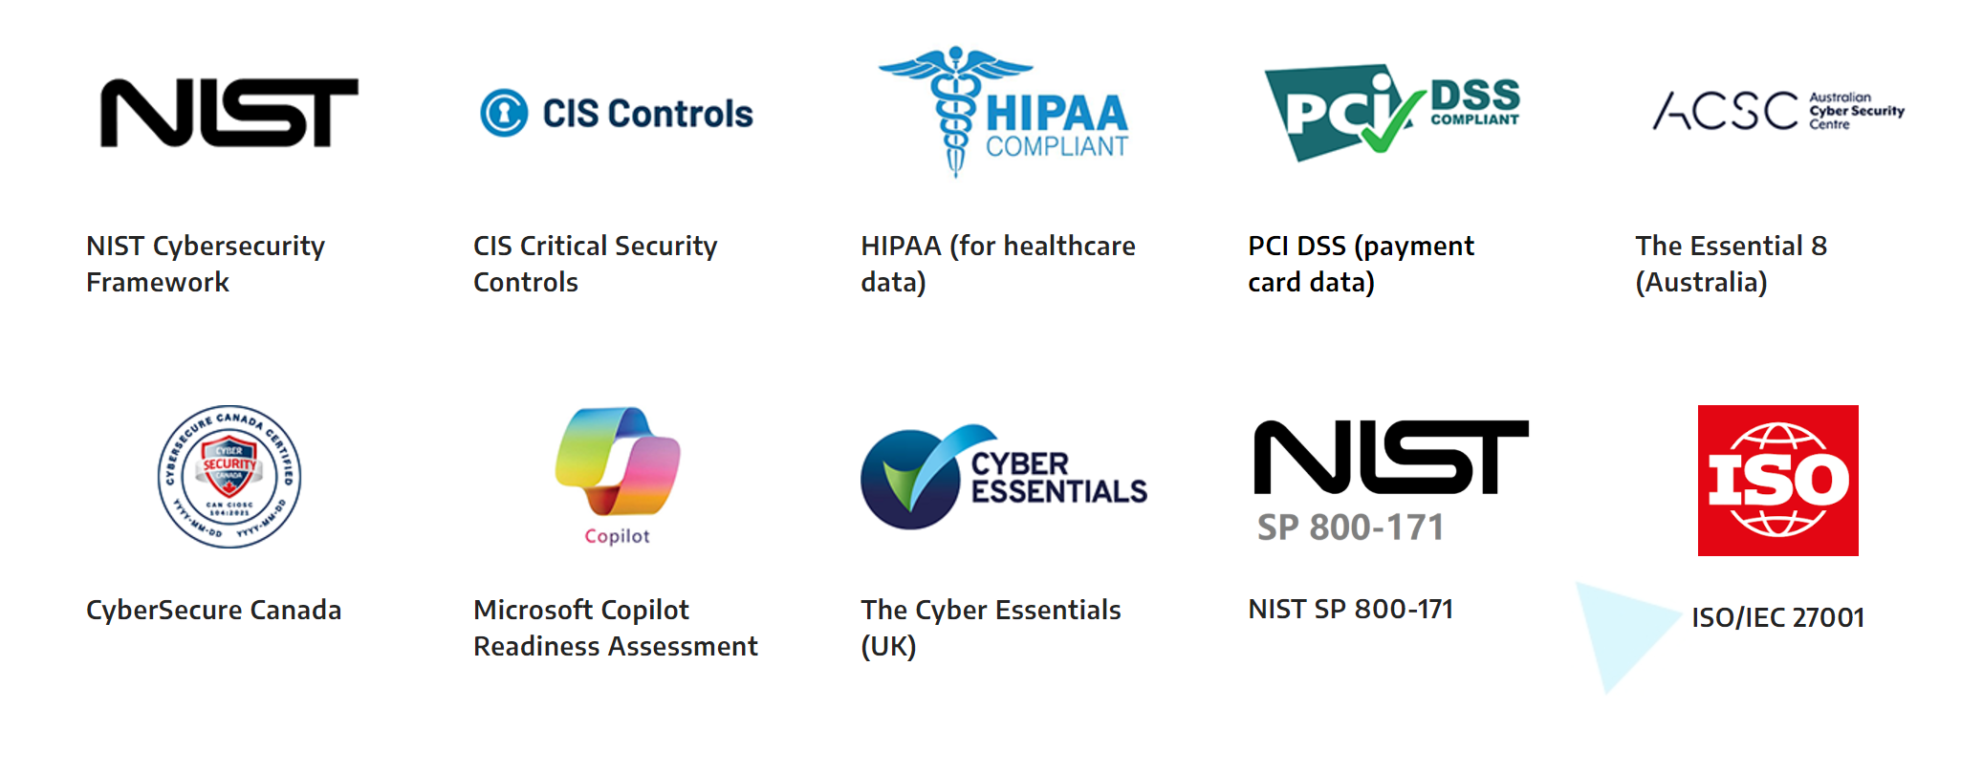

## **Microsoft Copilot Readiness Assessment**

Ensure that your sensitive data remains secure as you leverage the transformational capabilities of Microsoft Copilot.

Our Microsoft Copilot Readiness Assessment builds on the Microsoft 365 Data Scanning capability, and enables you to examine your organization’s Copilot readiness under four categories: User Information; Organizational Profile; Productivity Tools and Data Security

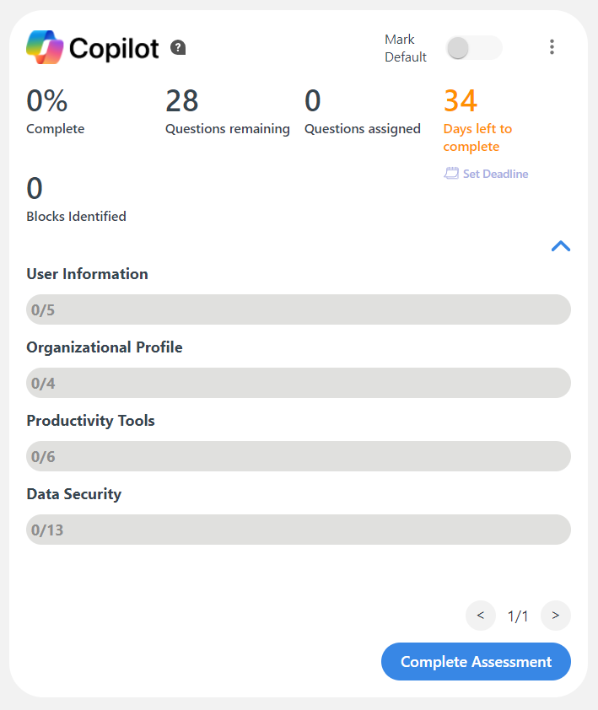

## **Active Directory Monitoring (On-prem and Azure)**

Easily monitor Active Directory (both on-prem and AD Azure) by adding an agent. View active accounts vs disabled accounts, information about users, devices and groups in domain, and users’ activity and password security status. Monitor any changes and do a basic clean-up.

With this information at hand, you can keep your Azure AD environment aligned with any governance, risk management, and compliance (GRC) requirements.

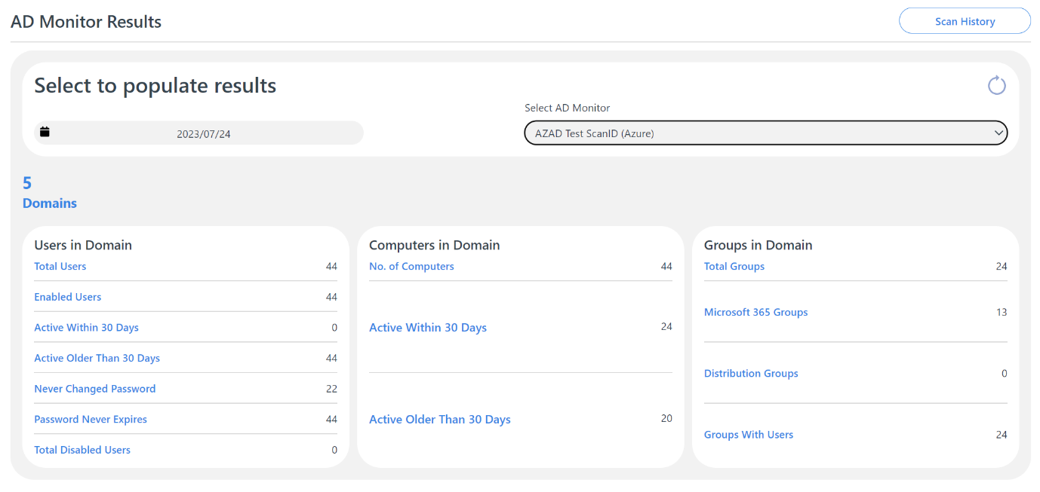

## **Microsoft Secure Score Dashboard**

Get help with implementing security settings within Microsoft Cloud to reduce the risk of data leakage and compromised accounts. Implement cyber security best practices to meet compliance requirements.

The Microsoft Secure Score Dashboard provides you with trends and metrics, along with the items that you must complete in order to increase the security posture of your Microsoft Cloud environment (Azure, Microsoft 365, etc).

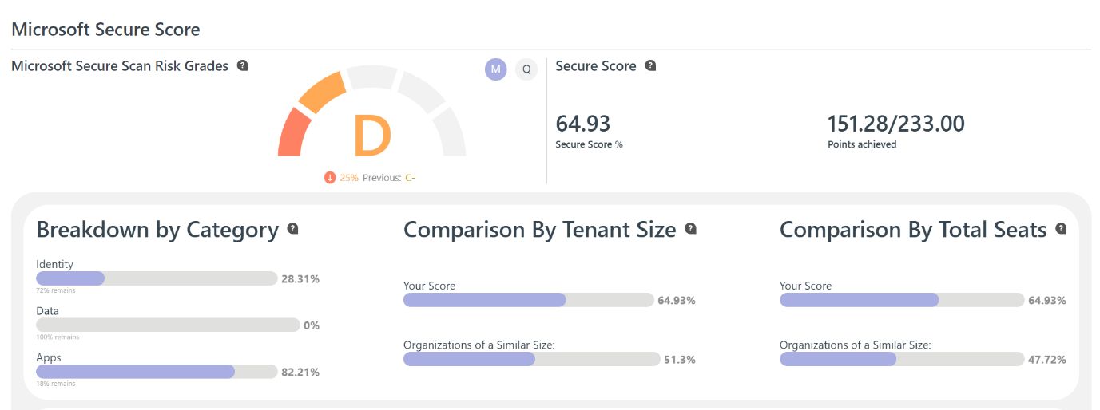

The Microsoft Secure Score Dashboard provides you trends and metrics, along with the items that you must complete in order to increase the security posture of your Microsoft Cloud environment (Azure, Microsoft 365, etc).

## **Microsoft Secure Score – Recommended Actions**

View recommended actions ranked by priority of what you should implement first within your Microsoft Cloud environment to strengthen security

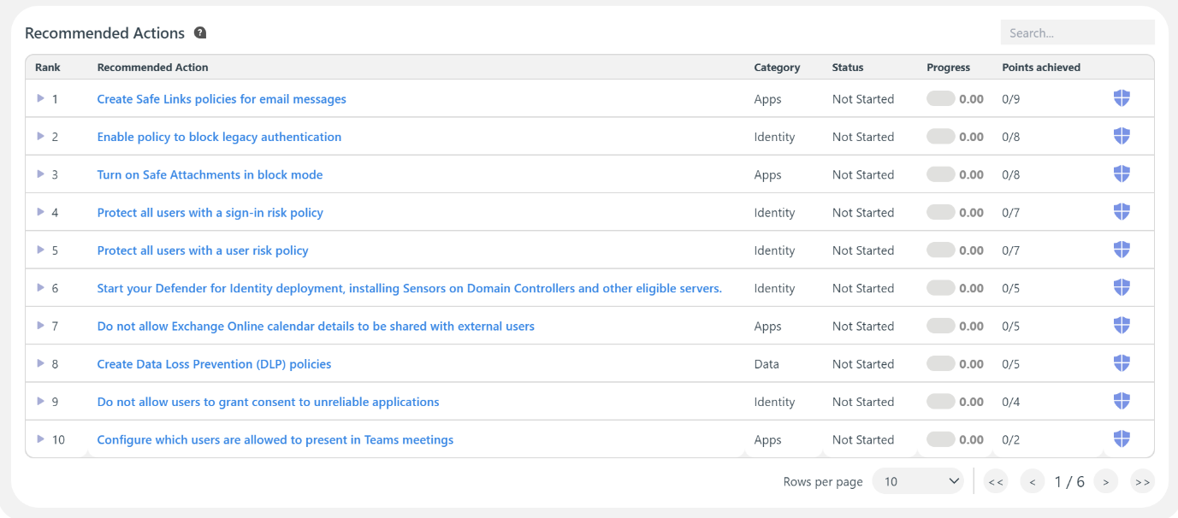

## **Industry Comparison**

Use the Industry Comparison Dashboard for insights into your organization’s risk scores relative to others in the same industry. Set the industry type for your instance, and see your scores benchmarked against comparable organizations. This dashboard enables you to understand your position on various risk metrics and to take action where needed.

